

**CAPSTONE PROJECT REPORT**

**Report 6 – Software User Guides**

– Ho Chi Minh City, December 2025–

**Table of Contents**

I. Project Report 3

1. Status Report 3

2. Team Involvements 3

3. Issues/Suggestions 3

II. Release Package & User Guides 4

1. Deliverable Package 4

1.1 Source codes & documents 4

1.2 Known Issues, Limitations & Restrictions 4

2. Installation Guides 4

2.1 System Requirements 4

2.2 Setup Files 4

2.3 Installation Instruction 4

3. User Manual 4

3.1 Terms and definitions 4

3.2 System requirements 4

3.3 Application Usage 5

3.4 Troubleshooting 5

2. Installation Guides 6

3. User Manual 12

# I. Project Report

## 1. Status Report

|  |  |  |  |
| --- | --- | --- | --- |
| **#** | **Work Item** | **Status** | **Notes (Work Item in Details)** |
| 1 |  | Pending |  |
| 2 |  | In Progress |  |
| 3 |  | Completed |  |

## 2. Team Involvements

|  |  |  |  |
| --- | --- | --- | --- |
| **#** | **Task** | **Member** | **Notes (Task Details, etc.)** |
| 1 |  | KienNT |  |
| 2 |  | TuanTV |  |
| 3 |  | AnhLM |  |

## 3. Issues/Suggestions

|  |  |  |  |
| --- | --- | --- | --- |
| **#** | **Issue** | **Status** | **Notes (Solution, Suggestion, etc.)** |
| 1 |  | Pending |  |
| 2 |  | In Progress |  |
| 3 |  | Completed |  |

# II. Release Package & User Guides

## 1. Deliverable Package

### 1.1 Source codes & documents

[The section will list all source programs, scripts, documents with version number in this release. You can see the example following table for reference, can customize or delete if not using belong to each project characteristics]

| **No.** | **Items** | **Sub-Items** | **Type** | **Version** |
| --- | --- | --- | --- | --- |
| **Code Package** | | | | |
| 1 | SM | SM Client | Modify | 1.1.2 |
| 2 | FT | Delayed Report | New | 1.1.0 |
| **Database** | | | | |
| 1 | Tables | FPT_DP_OB_District.sql | New | N/A |
| FPT_DP_OB_Master.sql | Modify | N/A |
| FPT_DP_IB_City.sql | Re-Use | N/A |
|  |  |  |
| 2 | Stored Procedures | FPT_DP_PROC_OB_UpdateCityStatus.sql | New | N/A |
| FPT_DP_PROC_OB_GetCityStatus.sql | Modify | N/A |
|  |  |  |
| **Documents** | | | | |
| 1 | Requirement | CCS_SRS_v1.0.doc | Modify | 1.0 |
| 2 | Deployment | SM_User Manual_(SMA Client)_v1.0.doc | Modify | 1.0 |
| 3 |  |  |  |  |

### 1.2 Known Issues, Limitations & Restrictions

[List out all known (pending) issues, limitation and restrictions in the final deliverable package]

## 2. Installation Guides

### 2.1 System Requirements

### 2.2 Setup Files

[List of installation scripts and setup files]

### 2.3 Installation Instruction

[Includes installation instructions and configuration guidelines]

## 3. User Manual

### 3.1 Terms and definitions

[Detail about terms and definitions used in this user guide.]

### 3.2 System requirements

[Define any system requirements necessary to support the application. These can include the supported host operating systems and network platforms, configurations, memory, peripherals, and companion software(s).]

### 3.3 Application Usage

#### a. Overview

[Descript the overview of the application and if could, insert the features workflow to help user has the overview of all the features in this application]

#### b. Feature 1

[Descript the purpose of this feature.]

[List of functions used in this feature.]

[Insert the user interface(s) of each function and provide step by step description of how to use that function.]

#### c. Feature 2

[Descript the purpose of this feature.]

[List of functions used in this feature.]

[Insert the user interface(s) of each function and provide step by step description of how to use that function.]

…

### 3.4 Troubleshooting

[Descript some common troubles while using application.]

**2.1.1 Hardware Requirements**

| **Component** | **Minimum** | **Recommended** |
| --- | --- | --- |
| CPU | Intel Core i3 2.0 GHz x64-bit | Intel Core i5/i7 3.0 GHz or higher |
| Memory | 4GB RAM | 8GB RAM (16GB for simulation features) |
| Storage Space | 20GB HDD/SSD | 50GB SSD |
| Graphics Card | Integrated GPU with WebGL 2.0 support | Dedicated GPU (NVIDIA GTX 1050 or AMD Radeon RX 560) |
| Network | Broadband Internet Connection (5 Mbps) | High-speed Internet (10+ Mbps for simulation) |
| Display | 1366x768 resolution | 1920x1080 or higher resolution |

**Table 1: Hardware Requirements**

**2.1.2 Software Requirements**

| **Component** | **Software and Version** | **Description** |
| --- | --- | --- |
| Operating System | Windows 10/11, macOS 10.15+, or Linux (Ubuntu 20.04+) | Operating system for running project |
| DBMS | SQL Server 2019 or Azure SQL Database | Database management system |
| Server Environment | .NET 8.0 SDK | Environment for running backend API |
| Frontend Environment | Node.js 18.17.0 or higher | Environment for running frontend application |
| Package Manager | NPM 9.x or higher | Package manager for frontend dependencies |
| IDE | Visual Studio Code 1.80+ or Visual Studio 2022 | Tool for viewing and editing code |
| VCS | Git 2.30+ | Tool for managing code version |
| Web Browser | Chrome 90+, Firefox 88+, Edge 90+, or Safari 14+ | Browser for accessing web application |
| Database Tool | SQL Server Management Studio (SSMS) 19+ or Azure Data Studio | Tool for database management |

**Table 2: Software Requirements**

**2.1.3 Additional Requirements for Development**

| **Component** | **Software and Version** | **Description** |
| --- | --- | --- |
| . NET CLI | . NET 8.0 SDK | Command-line interface for .NET development |
| EF Core Tools | Entity Framework Core 8.0 | Database migration and scaffolding tools |
| Postman/Thunder Client | Latest version | API testing tool (optional) |
| Docker Desktop | Latest version | Containerization platform (optional for deployment) |

**Table 3: Development Tools**

**2.2 Setup Files**

**2.2.1 Database Files**

* **lssctc_db-script-v5.sql**: Complete database schema script for SQL Server
* **seed-data.sql**: Initial seed data for system (users, roles, course categories, etc.)

**2.2.2 Backend Files**

* **lssctc-api. zip**: Complete backend API solution
  + Contains: Controllers, Services, Models, Repositories, and Configuration files
  + Main project: Lssctc.ProgramManagement
  + Shared library: Lssctc.Share

**2.2.3 Frontend Files**

* **lssctc-web.zip**: Complete frontend web application
  + Contains: React components, Pages, Routes, Layouts, and Assets
  + Main entry: src/main.jsx
  + Configuration: vite.config.js, package.json

**2.2.4 Configuration Files**

* **appsettings.json**: Backend API configuration (connection strings, JWT settings)
* **appsettings.Development.json**: Development-specific settings
* **.env. example**: Frontend environment variables template

**2.3 Installation Instruction**

**2.3.1 Setup Environment**

**Step 1: Install Required Software**

1. **Download and Install .NET 8.0 SDK**
   * Visit: <https://dotnet.microsoft.com/download/dotnet/8.0>
   * Download . NET 8.0 SDK for your operating system
   * Run installer and follow installation wizard
   * Verify installation:
2. dotnet --version
3. # Expected output: 8.0.x
4. **Download and Install Node.js 18.17.0 or higher**
   * Visit: <https://nodejs.org/>
   * Download LTS version (18.17.0 or newer)
   * Run installer and follow installation wizard
   * Verify installation:
5. node --version
6. # Expected output: v18.17.0 or higher
7. npm --version
8. # Expected output: 9.x or higher
9. **Download and Install SQL Server 2019**
   * Visit: <https://www.microsoft.com/en-us/sql-server/sql-server-downloads>
   * Download SQL Server 2019 Developer Edition (free)
   * Run installer and select:
     + Database Engine Services
     + SQL Server Replication
     + Client Tools Connectivity
   * Configure authentication mode: **Mixed Mode** (SQL Server and Windows Authentication)
   * Set SA password (remember this for connection string)
   * Verify installation using SQL Server Configuration Manager
10. **Download and Install SQL Server Management Studio (SSMS)**
    * Visit: <https://docs.microsoft.com/en-us/sql/ssms/download-sql-server-management-studio-ssms>
    * Download latest version (19.x)
    * Run installer
    * Launch SSMS and connect to local SQL Server instance
11. **Download and Install Visual Studio Code**
    * Visit: <https://code.visualstudio.com/>
    * Download for your operating system
    * Install recommended extensions:
      + C# Dev Kit
      + C# Extensions
      + JavaScript (ES6) code snippets
      + ESLint
      + Prettier - Code formatter
      + Thunder Client (for API testing)
12. **Download and Install Git**
    * Visit: <https://git-scm.com/downloads>
    * Download for your operating system
    * Run installer with default options
    * Verify installation:
13. git --version
14. # Expected output: git version 2.x

**Step 2: Configure Git**

# Set your name and email

git config --global user.name "Your Name"

git config --global user.email "your. email@example.com"

# Verify configuration

git config --list

**Step 3: Connect Git with GitHub Account**

# Generate SSH key (if not already exists)

ssh-keygen -t ed25519 -C "your.email@example.com"

# Start SSH agent

eval "$(ssh-agent -s)"

# Add SSH key to agent

ssh-add ~/.ssh/id_ed25519

# Copy public key to clipboard (Windows)

clip < ~/.ssh/id_ed25519.pub

# Copy public key to clipboard (macOS)

pbcopy < ~/.ssh/id_ed25519.pub

# Copy public key to clipboard (Linux)

cat ~/.ssh/id_ed25519.pub | xclip -selection clipboard

* Go to GitHub → Settings → SSH and GPG keys → New SSH key
* Paste your public key and save

**Step 4: Clone Repositories**

# Create project directory

mkdir lssctc-project

cd lssctc-project

# Clone backend repository

git clone https://github.com/hieuvau198/lssctc-api.git

# Clone frontend repository

git clone https://github.com/hieuvau198/lssctc-web.git

**2.3.2 Setup Database**

**Step 1: Create Database**

1. Open **SQL Server Management Studio (SSMS)**
2. Connect to your local SQL Server instance
3. Right-click on **Databases** → Select **New Database**
4. Database name: LSSCTC_DB
5. Click **OK**

**Step 2: Execute Database Script**

1. Open **lssctc_db-script-v5.sql** in SSMS
   * File → Open → File → Select lssctc_db-script-v5.sql
2. Ensure **LSSCTC_DB** is selected in database dropdown
3. Click **Execute** button or press F5
4. Wait for script execution to complete
5. Verify tables are created:
6. USE LSSCTC_DB;
7. GO
8. SELECT TABLE_SCHEMA, TABLE_NAME
9. FROM INFORMATION_SCHEMA.TABLES
10. WHERE TABLE_TYPE = 'BASE TABLE'
11. ORDER BY TABLE_NAME;
12. Expected output: 40+ tables including users, roles, courses, classes, quizzes, etc.

**Step 3: Execute Seed Data (Optional)**

1. Open **seed-data.sql** in SSMS
2. Execute script to populate initial data:
   * Default admin account
   * Course categories and levels
   * Course and class codes
   * Material types
3. Verify seed data:
4. SELECT * FROM users;
5. SELECT * FROM course_categories;
6. SELECT * FROM course_levels;

**Step 4: Verify Database Connection String**

* Server name: localhost or (local) or .
* Database name: LSSCTC_DB
* Authentication: SQL Server Authentication or Windows Authentication
* Example connection string:
* Server=localhost;Database=LSSCTC_DB;User Id=sa;Password=YourPassword;TrustServerCertificate=True

**2.3.3 Setup and Run Backend API**

**Step 1: Navigate to Backend Project**

cd lssctc-project/lssctc-api/Lssctc/Lssctc.ProgramManagement

**Step 2: Configure Application Settings**

1. Open **appsettings.json** in text editor or VS Code
2. Update connection string:
3. {
4. "ConnectionStrings": {
5. "lssctcDb": "Server=localhost;Database=LSSCTC_DB;User Id=sa;Password=YourSaPassword;TrustServerCertificate=True"
6. },
7. "JwtConfig": {
8. "Issuer": "LSSCTC_API",
9. "Audience": "LSSCTC_Web",
10. "Key": "your-secret-key-minimum-32-characters-long-for-security",
11. "TokenValidityInMinutes": 180
12. },
13. "EmailSettings": {
14. "Mail": "your-email@gmail.com",
15. "DisplayName": "LSSCTC System",
16. "Password": "your-app-password",
17. "Host": "smtp.gmail.com",
18. "Port": 587
19. }
20. }
21. **Generate JWT Secret Key** (recommended):
22. # Generate random 32-character key using PowerShell (Windows)
23. -join ((65..90) + (97..122) + (48..57) | Get-Random -Count 32 | ForEach-Object {[char]$_})
24. # Generate random 32-character key using openssl (macOS/Linux)
25. openssl rand -base64 32
26. **Configure Email Settings** (for OTP functionality):
    * Use Gmail account
    * Enable 2-Factor Authentication
    * Generate App Password: <https://myaccount.google.com/apppasswords>
    * Use App Password in configuration (not your Gmail password)

**Step 3: Restore NuGet Packages**

# Restore all dependencies

dotnet restore

# Expected output:

# Restore completed in X. XX sec

**Step 4: Build Project**

# Build project

dotnet build

# Expected output:

# Build succeeded.

# 0 Warning(s)

# 0 Error(s)

**Step 5: Run Backend API**

# Run in development mode

dotnet run

# Expected output:

# info: Microsoft. Hosting.Lifetime[14]

# Now listening on: http://localhost:5000

# Now listening on: https://localhost:5001

# info: Microsoft.Hosting. Lifetime[0]

# Application started. Press Ctrl+C to shut down.

**Step 6: Verify API is Running**

1. Open web browser
2. Navigate to: [**http://localhost:5000/swagger**](http://localhost:5000/swagger)
3. You should see Swagger UI with all API endpoints

**📷 INSERT SCREENSHOT HERE: Swagger UI Homepage**

File: screenshot_swagger_ui_homepage.png

Show: Swagger documentation page with API endpoints listed by category

(Authens, Courses, Classes, Quizzes, Materials, etc.)

1. Test authentication endpoint:
   * Expand **POST /api/Authens/login-username**
   * Click **Try it out**
   * Enter test credentials (if seeded)
   * Click **Execute**
   * Verify 200 OK response with JWT token

**Troubleshooting Backend Issues:**

| **Issue** | **Solution** |
| --- | --- |
| Port 5000 already in use | Change port in Properties/launchSettings.json or stop conflicting application |
| Database connection failed | Verify SQL Server is running, check connection string, verify database exists |
| NuGet restore failed | Check internet connection, clear NuGet cache: dotnet nuget locals all --clear |
| JWT authentication failed | Verify JWT Key is at least 32 characters, check Issuer and Audience match |

**2.3.4 Setup and Run Frontend Web Application**

**Step 1: Navigate to Frontend Project**

cd lssctc-project/lssctc-web

**Step 2: Install Dependencies**

# Install all npm packages

npm install

# Expected output:

# added XXX packages in XX.XXs

**Alternative: Clean Install (if issues occur)**

# Remove existing node_modules and package-lock

rm -rf node_modules package-lock.json

# Clear npm cache

npm cache clean --force

# Reinstall

npm install

**Step 3: Configure Environment Variables**

1. Create **.env** file in project root:
2. # Windows
3. copy .env.example .env
4. # macOS/Linux
5. cp .env.example .env
6. Edit **.env** file:
7. # Backend API URL
8. VITE_API_BASE_URL=http://localhost:5000/api
9. # Google OAuth Client ID (get from Google Cloud Console)
10. VITE_GOOGLE_CLIENT_ID=your-google-client-id. apps.googleusercontent.com

**Step 4: Configure Google OAuth (Optional)**

1. Visit: <https://console.cloud.google.com/>
2. Create new project or select existing
3. Enable Google+ API
4. Create OAuth 2.0 credentials:
   * Application type: Web application
   * Authorized JavaScript origins: http://localhost:5173
   * Authorized redirect URIs: http://localhost:5173/auth/callback
5. Copy Client ID and paste into .env file

**Step 5: Run Development Server**

# Start Vite development server

npm run dev

# Expected output:

# VITE v5.0.0 ready in 500 ms

#

# ➜ Local: http://localhost:5173/

# ➜ Network: use --host to expose

# ➜ press h + enter to show help

**Step 6: Verify Application is Running**

1. Open web browser
2. Navigate to: [**http://localhost:5173**](http://localhost:5173/)
3. You should see the LSSCTC login page

**📷 INSERT SCREENSHOT HERE: LSSCTC Login Page**

File: screenshot_lssctc_login_page_running.png

Show: Login page with LSSCTC branding, username/password fields,

"Sign in with Google" button, responsive design

**Step 7: Test Application**

1. Try logging in with seeded credentials:
   * Username: admin
   * Password: admin123 (or as configured in seed data)
2. Verify successful login and redirect to dashboard
3. Test navigation between pages
4. Verify API calls are working (check browser console for errors)

**📷 INSERT SCREENSHOT HERE: Browser Console Verification**

File: screenshot_browser_console_api_calls.png

Show: Browser DevTools Console tab with successful API requests

(200 OK status), no errors in red

**Step 8: Build for Production (Optional)**

# Build production bundle

npm run build

# Expected output:

# ✓ XXX modules transformed.

# dist/index.html X.XX kB

# dist/assets/index-XXXXXXXX.js XXX.XX kB

Build output will be in dist/ folder, ready for deployment.

**Step 9: Preview Production Build (Optional)**

# Preview production build locally

npm run preview

# Navigate to: http://localhost:4173

**Troubleshooting Frontend Issues:**

| **Issue** | **Solution** |
| --- | --- |
| npm install fails | Delete node_modules and package-lock.json, run npm install again |
| Port 5173 already in use | Kill process using port or change port in vite.config.js |
| API calls fail (CORS error) | Verify backend CORS configuration allows http://localhost:5173 |
| Google OAuth not working | Verify Client ID is correct, check redirect URIs in Google Console |
| Blank page after build | Check browser console for errors, verify environment variables |
| Module not found errors | Run npm install to ensure all dependencies are installed |

**2.3.5 Deployment to Production (Optional)**

**Backend Deployment Options:**

**Option 1: Deploy to Azure App Service**

1. Install Azure CLI
2. Login to Azure:
3. az login
4. Create App Service:
5. az webapp create --resource-group myResourceGroup --plan myAppServicePlan --name lssctc-api --runtime "DOTNET:8.0"
6. Deploy:
7. dotnet publish -c Release
8. az webapp deploy --resource-group myResourceGroup --name lssctc-api --src-path ./bin/Release/net8.0/publish. zip
9. Configure connection string in Azure Portal
10. Update JWT and Email settings

**Option 2: Deploy to Docker Container**

1. Create Dockerfile in backend project root:
2. FROM mcr.microsoft.com/dotnet/aspnet:8.0
3. WORKDIR /app
4. COPY ./publish .
5. ENTRYPOINT ["dotnet", "Lssctc.ProgramManagement.dll"]
6. Build and run:
7. dotnet publish -c Release -o ./publish
8. docker build -t lssctc-api .
9. docker run -p 5000:80 lssctc-api

**Frontend Deployment Options:**

**Option 1: Deploy to Vercel**

1. Install Vercel CLI:
2. npm install -g vercel
3. Login:
4. vercel login
5. Deploy:
6. vercel --prod
7. Configure environment variables in Vercel dashboard

**Option 2: Deploy to Azure Static Web Apps**

1. Build production bundle:
2. npm run build
3. Create Static Web App in Azure Portal
4. Connect to GitHub repository
5. Configure build settings:
   * App location: /
   * API location: (empty)
   * Output location: dist
6. Azure will automatically build and deploy on push

**Option 3: Deploy to Netlify**

1. Install Netlify CLI:
2. npm install -g netlify-cli
3. Build:
4. npm run build
5. Deploy:
6. netlify deploy --prod --dir=dist

**Database Deployment:**

**Deploy to Azure SQL Database**

1. Create Azure SQL Database in Azure Portal
2. Export local database using SSMS:
   * Right-click database → Tasks → Generate Scripts
   * Select all objects
   * Save script
3. Connect to Azure SQL Database
4. Execute script to create schema
5. Update connection string in backend configuration

**2.3.6 Post-Installation Verification Checklist**

* SQL Server is installed and running
* Database LSSCTC_DB is created with all tables
* Seed data is loaded successfully
* Backend API runs without errors on http://localhost:5000
* Swagger UI is accessible at http://localhost:5000/swagger
* JWT authentication works (test login endpoint)
* Frontend application runs on http://localhost:5173
* Login page displays correctly
* Can successfully login with test credentials
* API calls from frontend to backend work (check Network tab)
* No CORS errors in browser console
* Google OAuth login works (if configured)
* Environment variables are set correctly

**System Health Check:**

# Check backend health

curl http://localhost:5000/health

# Check database connection

# Execute in SSMS:

SELECT COUNT(*) as UserCount FROM users;

# Check frontend build

npm run build

# Verify no errors in output

**2.3.7 Default Access Credentials (After Seeding)**

| **Role** | **Username** | **Email** | **Default Password** |
| --- | --- | --- | --- |
| Admin | admin | [admin@lssctc.com](mailto:admin@lssctc.com) | Admin@123456 |
| Instructor | instructor1 | [instructor1@lssctc.com](mailto:instructor1@lssctc.com) | Instructor@123 |
| Trainee | trainee1 | trainee1@lssctc. com | Trainee@123 |
| Simulation Manager | sm1 | [sm1@lssctc.com](mailto:sm1@lssctc.com) | SM@123456 |

**First Login Steps:**

1. Navigate to: [http://localhost:5173](http://localhost:5173/)
2. Login with admin credentials
3. Go to Profile → Change Password
4. Set new secure password
5. Repeat for all default accounts

**2.3.8 Support and Resources**

**Documentation:**

* API Documentation: <http://localhost:5000/swagger>
* Frontend README: lssctc-web/README.md
* Backend README: lssctc-api/README.md

**Repositories:**

* Frontend: <https://github.com/hieuvau198/lssctc-web>
* Backend: <https://github.com/hieuvau198/lssctc-api>

**Common Commands Reference:**

# Backend

dotnet restore # Restore packages

dotnet build # Build project

dotnet run # Run development

dotnet publish -c Release # Build for production

# Frontend

npm install # Install dependencies

npm run dev # Run development

npm run build # Build production

npm run preview # Preview production build

npm run lint # Run ESLint

# Database

# Connect to SQL Server

sqlcmd -S localhost -U sa -P YourPassword

# Git

git pull # Update code

git status # Check changes

git add . # Stage changes

git commit -m "message" # Commit changes

git push # Push to remote

### 3. User Manual

#### 3.1 Terms and definitions

|  |  |
| --- | --- |
| **Term** | **Definition** |
| LSSCTC | Learner Management and 3D Simulation System for Crane Training Center |
| Admin | System administrator with full access to all features and user management |
| Instructor | Teacher/trainer who creates course content, quizzes, and evaluates trainees |
| Trainee | Student enrolled in crane operation training courses |
| Program Manager | Role responsible for curriculum design and course orchestration |
| Simulation Manager | Role responsible for managing 3D simulation components and scenarios |
| Training Program | Complete curriculum consisting of multiple courses leading to certification |
| Course | Individual training module covering specific crane operation topics |
| Section | Subdivision within a course containing organized activities |
| Activity | Learning task within a section (material, quiz, or practice) |
| Learning Material | Educational content (PDF, video, image, URL) provided to trainees |
| Quiz | Assessment containing multiple-choice or single-choice questions |
| Practice | Hands-on simulation task for skill development and evaluation |
| Class | Group of trainees enrolled in a program with scheduled sessions |
| Timeslot | Scheduled session for class instruction with date, time, and instructor |
| Enrollment | Trainee's registration and participation in a specific class |
| Activity Record | Trainee's progress and completion status for an activity |
| Quiz Attempt | Trainee's submission of a quiz with scored results |
| Practice Attempt | Trainee's completion of a practice session with performance metrics |
| Simulation Component | 3D model or asset used in crane operation simulation environment |
| Brand Model | Specific crane manufacturer and model configuration |
| JWT | JSON Web Token - authentication token for API access |
| OTP | One-Time Password - 6-digit code for password reset verification |
| WebGL | Web Graphics Library - browser technology for 3D rendering |

#### 3.2 System requirements

For End Users (Trainees, Instructors):

* Operating System:
  + Windows 10/11 (64-bit)
  + macOS 10.15 (Catalina) or later
  + Linux (Ubuntu 20.04+ or equivalent)
* Web Browser:
  + Google Chrome 90+ (Recommended)
  + Mozilla Firefox 88+
  + Safari 14+ (macOS only)
  + Microsoft Edge 90+
* Internet Connection:
  + Minimum: 5 Mbps (for video streaming and general use)
  + Recommended: 10 Mbps (for 3D simulation)
* Display Resolution:
  + Minimum: 1366x768
  + Recommended: 1920x1080 or higher
* Input Devices:
  + Mouse and keyboard (required)
  + Trackpad supported but not recommended for simulation

For Simulation Features:

* RAM:
  + Minimum: 8GB
  + Recommended: 16GB
* Graphics Card:
  + Dedicated GPU with WebGL 2.0 support
  + NVIDIA GTX 1050 or equivalent
  + AMD Radeon RX 560 or equivalent
* Storage:
  + 2GB free space for cached 3D models and textures
* CPU:
  + Minimum: Intel Core i5 or AMD Ryzen 5
  + Recommended: Intel Core i7 or AMD Ryzen 7

For System Administrators:

* All of the above, plus:
* Access to SQL Server Management Studio or Azure Data Studio
* Network access to application server and database server
* Remote desktop or SSH access to servers (for on-premise deployment)

Browser Compatibility Matrix:

| **Feature** | **Chrome** | **Firefox** | **Safari** | **Edge** |
| --- | --- | --- | --- | --- |
| Authentication | ✅ | ✅ | ✅ | ✅ |
| Course Management | ✅ | ✅ | ✅ | ✅ |
| Quiz Taking | ✅ | ✅ | ✅ | ✅ |
| Video Materials | ✅ | ✅ | ✅ | ✅ |
|  |  |  |  |  |
| File Upload | ✅ | ✅ | ✅ | ✅ |

✅ Fully Supported | ⚠️ Limited Support | ❌ Not Supported

#### 3.3 Application Usage

##### **a. Overview**

System Architecture:

The LSSCTC system is a web-based Learning Management System integrated with 3D crane operation simulation capabilities. It consists of:

1. Frontend (Web Application): React-based single-page application
2. Backend (API): .NET 8 RESTful API with JWT authentication
3. Database: SQL Server relational database
4. 3D Engine: WebGL-based simulation environment (planned)

User Roles and Permissions:

┌─────────────────────────────────────────────────────────┐

│ ADMIN (Full Access) │

├─────────────────────────────────────────────────────────┤

│ • Manage all users, courses, programs, classes │

│ • View system-wide analytics and reports │

│ • Configure system settings │

└─────────────────────────────────────────────────────────┘

┌──────────────────────┬──────────────────────────────────┐

│ PROGRAM MANAGER │ SIMULATION MANAGER │

├──────────────────────┼──────────────────────────────────┤

│ • Design programs │ • Manage 3D components │

│ • Organize courses │ • Configure crane models │

│ • Set prerequisites │ • Create scenarios │

└──────────────────────┴──────────────────────────────────┘

┌─────────────────────────────────────────────────────────┐

│ INSTRUCTOR (Content Creator) │

├─────────────────────────────────────────────────────────┤

│ • Create courses, sections, activities │

│ • Upload learning materials │

│ • Create quizzes and practice sessions │

│ • Grade and provide feedback to trainees │

│ • View class performance analytics │

└─────────────────────────────────────────────────────────┘

┌─────────────────────────────────────────────────────────┐

│ TRAINEE (Learner) │

├─────────────────────────────────────────────────────────┤

│ • Enroll in classes │

│ • Access course materials │

│ • Take quizzes and practice sessions │

│ • View personal progress and scores │

└─────────────────────────────────────────────────────────┘

Application Workflow:

1. SETUP PHASE (Admin/Program Manager)

├─ Create Training Programs

├─ Add Courses to Programs

├─ Define Course Structure (Sections)

└─ Create Classes with Schedules

2. CONTENT CREATION (Instructor)

├─ Add Activities to Sections

│ ├─ Upload Learning Materials (PDF, Video, URL)

│ ├─ Create Quizzes with Questions

│ └─ Design Practice Sessions

└─ Set Deadlines and Grading Criteria

3. ENROLLMENT (Trainee)

├─ Browse Available Classes

├─ Enroll in Desired Class

└─ Wait for Admin/Instructor Approval

4. LEARNING (Trainee)

├─ Access Course Content

├─ Complete Activities in Sequence

│ ├─ Study Materials

│ ├─ Take Quizzes

│ └─ Complete Practice Sessions

└─ Track Progress

5. EVALUATION (System/Instructor)

├─ Auto-grade Quizzes

├─ Score Practice Sessions

├─ Generate Performance Reports

└─ Determine Certification Readiness

6. COMPLETION (Trainee)

├─ Achieve Passing Scores

├─ Complete All Required Activities

└─ Receive Certificate (if applicable)

Main Features by Role:

|  |  |  |  |  |  |
| --- | --- | --- | --- | --- | --- |
| **Feature** | **Admin** | **Program Manager** | **Instructor** | **Trainee** | **Simulation Manager** |
| User Management | ✅ | ❌ | ❌ | ❌ | ❌ |
| Program Design | ✅ | ✅ | ❌ | ❌ | ❌ |
| Course Creation | ✅ | ✅ | ✅ | ❌ | ❌ |
| Class Management | ✅ | ❌ | ✅ | ❌ | ❌ |
| Material Upload | ✅ | ❌ | ✅ | ❌ | ❌ |
| Quiz Creation | ✅ | ❌ | ✅ | ❌ | ❌ |
| Practice Design | ✅ | ❌ | ✅ | ❌ | ❌ |
| Enrollment | ✅ | ❌ | ✅ | ✅ | ❌ |
| Take Quizzes | ❌ | ❌ | ❌ | ✅ | ❌ |
| Practice Sessions | ❌ | ❌ | ❌ | ✅ | ❌ |
| 3D Components | ✅ | ❌ | ❌ | ❌ | ✅ |
| Analytics | ✅ | ✅ | ✅ | ✅ (own) | ✅ |

##### **b. Feature 1: Authentication & User Management**

Purpose: Secure user authentication with multiple login methods and role-based access control

Available Functions:

1. Login with Username/Password
2. Login with Email/Password
3. Login with Google OAuth
4. Password Reset (OTP-based)
5. Logout
6. Profile View and Update

###### 1.1 Login with Username

Step-by-Step Instructions:

1. Open web browser and navigate to the LSSCTC application URL
2. You will see the login page

📷 INSERT SCREENSHOT HERE: Login Page

File: screenshot_login_page.png

Show: Login form with username field, password field, "Remember Me" checkbox,

"Login" button, "Forgot Password?" link, "Sign in with Google" button

1. Enter your Username in the first input field
2. Enter your Password in the second input field
3. (Optional) Check "Remember Me" to save credentials securely
4. Click the "Login" button

📷 INSERT SCREENSHOT HERE: Login Form Filled

File: screenshot_login_filled.png

Show: Form with example username entered, password masked with dots

1. If credentials are correct:
   * System validates username and password
   * JWT token is generated
   * Token is stored in browser cookies
   * User is redirected to role-specific dashboard

📷 INSERT SCREENSHOT HERE: Successful Login Redirect

File: screenshot_dashboard_after_login.png

Show: Dashboard page with user's name in header, navigation menu visible

1. If credentials are incorrect:
   * Error message appears: "Invalid username or password"
   * Input fields are highlighted in red
   * User can retry login

📷 INSERT SCREENSHOT HERE: Login Error

File: screenshot_login_error.png

Show: Error message displayed above form in red color

API Endpoint Used:

POST /api/Authens/login-username

Request Body:

{

"username": "string",

"password": "string"

}

Response (200 OK):

{

"userName": "string",

"accessToken": "eyJhbGciOiJIUzI1NiIs.. .",

"expiresIn": 10800

}

###### 1.2 Login with Google OAuth

Step-by-Step Instructions:

1. On the login page, click the "Sign in with Google" button

📷 INSERT SCREENSHOT HERE: Google Login Button

File: screenshot_google_login_button.png

Show: Blue button with Google logo and text "Sign in with Google"

1. Google OAuth popup window opens
2. Select your Google account from the list

📷 INSERT SCREENSHOT HERE: Google Account Selection

File: screenshot_google_account_selection.png

Show: Google's account chooser interface

1. Grant permission for LSSCTC to access your profile
2. System validates Google access token
3. If your Google email is registered in LSSCTC:
   * User is authenticated
   * JWT token is issued
   * Redirect to dashboard

📷 INSERT SCREENSHOT HERE: Google Login Success

File: screenshot_google_login_success.png

Show: Brief loading screen then dashboard

1. If email is NOT registered:
   * Error message: "Account with this email does not exist"
   * Contact administrator to link Google account

📷 INSERT SCREENSHOT HERE: Google Login Error

File: screenshot_google_login_error.png

Show: Alert message explaining email not found

API Endpoint Used:

POST /api/Authens/login-google

Request Body:

{

"accessToken": "ya29.a0AfH6SMBx..."

}

Response (200 OK):

{

"userName": "string",

"accessToken": "eyJhbGciOiJIUzI1NiIs...",

"expiresIn": 10800

}

###### 1.3 Forgot Password (OTP Reset)

Step-by-Step Instructions:

Phase 1: Request OTP

1. On login page, click "Forgot Password?" link

📷 INSERT SCREENSHOT HERE: Forgot Password Link

File: screenshot_forgot_password_link.png

Show: Link positioned below login button

1. You are redirected to Forgot Password page
2. Enter your registered Email Address

📷 INSERT SCREENSHOT HERE: Forgot Password Page

File: screenshot_forgot_password_page.png

Show: Email input field, "Send OTP" button, breadcrumb navigation

1. Click "Send OTP" button
2. System sends 6-digit OTP code to your email
3. Success message appears: "OTP code has been sent to your email"

📷 INSERT SCREENSHOT HERE: OTP Sent Confirmation

File: screenshot_otp_sent_message.png

Show: Green success message banner

1. Note: There is a 60-second cooldown between OTP requests

Phase 2: Verify OTP

1. Check your email inbox for OTP code

📷 INSERT SCREENSHOT HERE: Email with OTP

File: screenshot_otp_email. png

Show: Email client showing OTP code message from LSSCTC

1. Enter the 6-digit OTP code in verification form
2. Code is valid for 5 minutes

📷 INSERT SCREENSHOT HERE: OTP Verification Form

File: screenshot_otp_verification_form.png

Show: Six separate input boxes for OTP digits, "Verify" button, "Resend OTP" link

1. Click "Verify" button
2. If OTP is correct, proceed to password reset

Phase 3: Reset Password

1. Enter new password (minimum 6 characters)
2. Confirm new password by retyping

📷 INSERT SCREENSHOT HERE: Reset Password Form

File: screenshot_reset_password_form. png

Show: Two password input fields (New Password, Confirm Password), requirements checklist,

"Reset Password" button

1. Password requirements:
   * Minimum 6 characters
   * Both fields must match
2. Click "Reset Password" button
3. Success message: "Password reset successfully"
4. Click "Go to Login" to return to login page

📷 INSERT SCREENSHOT HERE: Password Reset Success

File: screenshot_password_reset_success. png

Show: Success confirmation page with "Go to Login" button

API Endpoints Used:

POST /api/Authens/forgot-password (Request OTP)

POST /api/Authens/verify-otp (Verify Code)

POST /api/Authens/reset-password (Set New Password)

Troubleshooting:

* OTP not received? Check spam folder, wait for cooldown (60s), try again
* OTP expired? Request new OTP
* OTP incorrect? Re-check email, ensure correct digits entered

###### 1.4 Logout

Step-by-Step Instructions:

1. Click on your Avatar/Profile Icon in the top-right header

📷 INSERT SCREENSHOT HERE: Header with Avatar

File: screenshot_header_avatar.png

Show: Top navigation bar with user avatar in corner

1. Dropdown menu appears with user information
2. Click "Logout" option

📷 INSERT SCREENSHOT HERE: Logout Dropdown

File: screenshot_logout_dropdown.png

Show: Dropdown menu showing: Profile, Settings, Logout options

1. Confirmation dialog may appear: "Are you sure you want to logout?"
2. Click "Confirm"
3. System:
   * Revokes JWT token
   * Adds token to blacklist (Redis cache)
   * Clears cookies
   * Redirects to login page

📷 INSERT SCREENSHOT HERE: After Logout

File: screenshot_after_logout.png

Show: Login page displayed after successful logout

API Endpoint Used:

POST /api/Authens/logout

Headers:

Authorization: Bearer <token>

Response (200 OK):

{

"message": "Logged out"

}

Note: After logout, previous JWT token becomes invalid immediately.

##### **c. Feature 2: Admin - Course Management**

Purpose: Create, organize, and manage training courses

Available Functions:

1. View All Courses (with pagination, search, sort)
2. Create New Course
3. Edit Course Details
4. Delete Course (soft delete)
5. Assign Course to Programs
6. View Course Enrollments

###### 2.1 View Courses List

Step-by-Step Instructions:

1. Login as Admin
2. Navigate to Admin Dashboard
3. Click "Courses" in the sidebar menu

📷 INSERT SCREENSHOT HERE: Admin Sidebar Navigation

File: screenshot_admin_sidebar.png

Show: Left sidebar with menu items: Dashboard, Users, Programs, Courses (highlighted),

Classes, etc.

1. Courses page displays with list of all courses

📷 INSERT SCREENSHOT HERE: Courses List Page

File: screenshot_courses_list.png

Show: Table/grid view with courses displaying:

- Course name, code, category, level

- Duration, price, status (Active/Inactive)

- Course thumbnail image

- Action buttons (View, Edit, Delete)

- Search bar at top

- Pagination controls at bottom

1. Search Courses:
   * Enter keyword in search box (e.g., "crane operation")
   * Results filter in real-time

📷 INSERT SCREENSHOT HERE: Course Search Results

File: screenshot_courses_search. png

Show: Search box with query entered, filtered results displayed below

1. Sort Courses:
   * Click column headers to sort (Name, Date, Duration, Price)
   * Arrow icon indicates sort direction (ascending/descending)

📷 INSERT SCREENSHOT HERE: Sorted Courses

File: screenshot_courses_sorted.png

Show: Column header with sort arrow, data sorted accordingly

1. Pagination:
   * View 10, 25, 50, or 100 courses per page
   * Use navigation buttons: Previous, 1, 2, 3, .. ., Next

API Endpoint Used:

GET /api/Courses/paged? pageNumber=1&pageSize=10&searchTerm=crane&sortBy=name&sortDirection=asc

Response (200 OK):

{

"items": [ {... course objects...} ],

"pageNumber": 1,

"pageSize": 10,

"totalPages": 5,

"totalCount": 47,

"hasPreviousPage": false,

"hasNextPage": true

}

###### 2.2 Create New Course

Step-by-Step Instructions:

1. On Courses page, click "Add New Course" button

📷 INSERT SCREENSHOT HERE: Add Course Button

File: screenshot_add_course_button.png

Show: Blue button with "+" icon and "Add New Course" text

1. Modal dialog or new page opens with course creation form

📷 INSERT SCREENSHOT HERE: Create Course Form (Empty)

File: screenshot_create_course_form_empty.png

Show: Form with fields:

- Course Name* (text input)

- Course Code* (text input with auto-generate option)

- Description (textarea)

- Category* (dropdown)

- Level* (dropdown: Entry/Standard/Expert)

- Duration (Hours)* (number input)

- Price (number input with currency symbol)

- Image URL (text input + upload button)

- Active Status (toggle switch)

- Save and Cancel buttons

1. Fill in Required Fields (marked with *):
   * Course Name: "Mobile Crane Operation Basics"
   * Course Code: Auto-generated (CO000023) or enter manually
   * Category: Select from dropdown (e.g., "Mobile Crane")
   * Level: Select "Entry", "Standard", or "Expert"
   * Duration: Enter hours (e.g., 40)

📷 INSERT SCREENSHOT HERE: Create Course Form (Filled - Part 1)

File: screenshot_create_course_form_filled1.png

Show: Form with basic fields filled in

1. Fill in Optional Fields:
   * Description: "This course covers fundamental mobile crane operations..."
   * Price: 1500.00
   * Image URL: Paste URL or click "Upload Image" button

📷 INSERT SCREENSHOT HERE: Image Upload Dialog

File: screenshot_image_upload_dialog.png

Show: File picker dialog or drag-drop zone for image upload

* Active Status: Toggle ON (green) or OFF (gray)

📷 INSERT SCREENSHOT HERE: Create Course Form (Filled - Complete)

File: screenshot_create_course_form_filled_complete.png

Show: Form completely filled with all data, Active toggle ON

1. Click "Save" button
2. System validates inputs:
   * Required fields are not empty
   * Duration is positive number
   * Price is valid format
   * Course code is unique
3. Success message: "Course created successfully"

📷 INSERT SCREENSHOT HERE: Course Creation Success

File: screenshot_course_created_success.png

Show: Green toast/alert message at top of page

1. New course appears in courses list

📷 INSERT SCREENSHOT HERE: New Course in List

File: screenshot_new_course_in_list. png

Show: Courses list with newly created course highlighted or at top

API Endpoint Used:

POST /api/Courses

Request Body:

{

"name": "Mobile Crane Operation Basics",

"description": "This course covers fundamental mobile crane operations...",

"categoryId": 3,

"levelId": 1,

"price": 1500.00,

"isActive": true,

"imageUrl": "https://example.com/images/course. jpg",

"durationHours": 40,

"courseCodeName": "CO000023"

}

Response (200 OK):

{

"id": 23,

"name": "Mobile Crane Operation Basics",

...

}

Validation Errors:

📷 INSERT SCREENSHOT HERE: Course Validation Errors

File: screenshot_course_validation_errors.png

Show: Form with red borders on invalid fields, error messages below each field:

- "Course name is required"

- "Duration must be greater than 0"

- "Invalid price format"

###### 2.3 Edit Course

Step-by-Step Instructions:

1. In courses list, find the course you want to edit
2. Click Edit Icon (pencil icon) in Actions column

📷 INSERT SCREENSHOT HERE: Edit Course Button

File: screenshot_edit_course_button.png

Show: Row in courses table with Edit icon button highlighted

1. Edit course modal/page opens with existing data pre-filled

📷 INSERT SCREENSHOT HERE: Edit Course Form (Pre-filled)

File: screenshot_edit_course_form_prefilled.png

Show: Same form as Create but with existing course data populated

1. Modify fields as needed:
   * Change course name
   * Update description
   * Adjust price or duration
   * Change category or level
   * Update image
   * Toggle active status

📷 INSERT SCREENSHOT HERE: Edit Course Form (Modified)

File: screenshot_edit_course_form_modified. png

Show: Form with some fields changed (e.g., price updated, description expanded)

1. Click "Update" or "Save Changes" button
2. Confirmation message: "Course updated successfully"

📷 INSERT SCREENSHOT HERE: Course Update Success

File: screenshot_course_updated_success.png

Show: Success toast message

1. Changes are reflected immediately in courses list

API Endpoint Used:

PUT /api/Courses/{id}

Request Body:

{

"name": "Mobile Crane Operation Basics - Updated",

"description": "Updated description.. .",

"categoryId": 3,

"levelId": 2,

"price": 1800.00,

"isActive": true,

"imageUrl": "https://example.com/images/course-updated.jpg",

"durationHours": 45,

"courseCodeName": "CO000023"

}

Response (200 OK):

{

"id": 23,

"name": "Mobile Crane Operation Basics - Updated",

...

}

###### 2.4 Delete Course

Step-by-Step Instructions:

1. In courses list, find course to delete
2. Click Delete Icon (trash icon) in Actions column

📷 INSERT SCREENSHOT HERE: Delete Course Button

File: screenshot_delete_course_button.png

Show: Row with Delete icon (red trash can) highlighted

1. Confirmation dialog appears:
   * "Are you sure you want to delete this course?"
   * "This action cannot be undone."
   * Course name displayed for confirmation

📷 INSERT SCREENSHOT HERE: Delete Confirmation Dialog

File: screenshot_delete_course_confirmation.png

Show: Modal dialog with warning icon, confirmation message, course name,

"Cancel" and "Delete" buttons

1. Click "Delete" button to confirm
2. System checks:
   * Course is not assigned to active programs
   * No active enrollments exist
3. If validation passes:
   * Course is soft-deleted (is_deleted = true)
   * Success message: "Course deleted successfully"
   * Course removed from list

📷 INSERT SCREENSHOT HERE: Course Deletion Success

File: screenshot_course_deleted_success.png

Show: Success message, course no longer in list

1. If validation fails:
   * Error message: "Cannot delete course: It is assigned to active programs"
   * Course remains in list

📷 INSERT SCREENSHOT HERE: Course Deletion Error

File: screenshot_course_deletion_error.png

Show: Red error message explaining why deletion failed

API Endpoint Used:

DELETE /api/Courses/{id}

Response (204 No Content) - Success

OR

Response (400 Bad Request) - Cannot delete

{

"message": "Cannot delete course: It is assigned to active programs"

}

Note: Deleted courses are soft-deleted (not physically removed from database) and can be restored by admin if needed.

##### **d. Feature 3: Admin - Class Management**

Purpose: Organize trainees into classes, assign instructors, and manage schedules

Available Functions:

1. View All Classes
2. Create New Class
3. Edit Class Details
4. View Class Enrollments
5. Approve/Reject Enrollments
6. Manage Class Timeslots (Schedule)
7. Assign Instructors

###### 3.1 View Classes List

Step-by-Step Instructions:

1. From Admin Dashboard, click "Classes" in sidebar

📷 INSERT SCREENSHOT HERE: Classes Menu Item

File: screenshot_admin_classes_menu.png

Show: Sidebar with Classes menu item highlighted

1. Classes list page displays

📷 INSERT SCREENSHOT HERE: Classes List Page

File: screenshot_classes_list_page.png

Show: Table/card view displaying:

- Class name, class code

- Program name

- Instructor name

- Start date / End date

- Capacity (15/30 - enrolled/total)

- Status badge (Draft/Open/InProgress/Completed/Cancelled)

- Action buttons (View Details, Edit, Manage Enrollments)

- Filter options at top (By status, by program, by instructor)

- Search bar

- "Create New Class" button

1. Filter Classes:
   * By Status dropdown: All, Draft, Open, In Progress, Completed
   * By Program dropdown
   * By Instructor dropdown

📷 INSERT SCREENSHOT HERE: Class Filters Applied

File: screenshot_classes_filtered.png

Show: Filters selected, only matching classes displayed

1. View Class Details:
   * Click on class name or "View Details" button

📷 INSERT SCREENSHOT HERE: Class Detail Page

File: screenshot_class_detail_page.png

Show: Detailed view showing:

- Class header (name, code, status)

- Program information

- Instructor information with avatar

- Schedule (list of timeslots with dates/times)

- Enrolled trainees list

- Class statistics (completion rate, average score)

- Edit and Manage buttons

API Endpoint Used:

GET /api/Classes/paged? pageNumber=1&pageSize=10&status=Open

Response:

{

"items": [

{

"id": 15,

"name": "Mobile Crane Class - Spring 2025",

"classCode": "CL000015",

"programId": 5,

"programName": "Professional Crane Operator Program",

"instructorId": 12,

"instructorName": "John Instructor",

"startDate": "2025-03-01T00:00:00",

"endDate": "2025-06-30T00:00:00",

"capacity": 30,

"enrolledCount": 15,

"status": "Open"

},

...

],

... pagination...

}

###### 3.2 Create New Class

Step-by-Step Instructions:

1. On Classes page, click "Create New Class" button

📷 INSERT SCREENSHOT HERE: Create Class Button

File: screenshot_create_class_button.png

Show: Button with "+" icon in classes page header

1. Class creation form appears (multi-step or single form)

Step 1: Basic Information

📷 INSERT SCREENSHOT HERE: Create Class Form - Step 1

File: screenshot_create_class_step1.png

Show: Form with fields:

- Class Name* (text input)

- Class Code* (auto-generated or manual)

- Program* (dropdown with search)

- Description (textarea)

- "Next" button

1. Fill in basic information:
   * Class Name: "Mobile Crane Class - Spring 2025"
   * Class Code: Auto-generated "CL000025"
   * Program: Select from dropdown
   * Description: Optional text
2. Click "Next"

Step 2: Instructor & Schedule

📷 INSERT SCREENSHOT HERE: Create Class Form - Step 2

File: screenshot_create_class_step2.png

Show: Form with fields:

- Instructor* (dropdown with instructor profiles)

- Start Date* (date picker)

- End Date* (date picker)

- Capacity* (number input)

- "Previous" and "Next" buttons

1. Assign instructor:

* Select from dropdown list
* Shows instructor name and specialization

1. Set dates:
   * Start Date: Use date picker (e.g., 2025-03-01)
   * End Date: Must be after start date
2. Set capacity: Max number of trainees (e.g., 30)
3. Click "Next"

Step 3: Status & Review

📷 INSERT SCREENSHOT HERE: Create Class Form - Step 3

File: screenshot_create_class_step3.png

Show: Form with:

- Status dropdown (Draft/Open)

- Summary of entered information

- "Previous" and "Create Class" buttons

1. Select initial status:
   * Draft: Class is created but not visible to trainees
   * Open: Class is open for enrollment immediately
2. Review all information
3. Click "Create Class" button
4. Success message: "Class created successfully"

📷 INSERT SCREENSHOT HERE: Class Created Success

File: screenshot_class_created_success. png

Show: Success toast, redirect to class detail page

API Endpoint Used:

POST /api/Classes

Request Body:

{

"name": "Mobile Crane Class - Spring 2025",

"classCode": "CL000025",

"programId": 5,

"instructorId": 12,

"startDate": "2025-03-01T00:00:00",

"endDate": "2025-06-30T00:00:00",

"capacity": 30,

"description": "Spring 2025 mobile crane training class",

"status": "Open"

}

Response (200 OK):

{

"id": 25,

"name": "Mobile Crane Class - Spring 2025",

...

}

###### 3.3 Manage Class Enrollments

Step-by-Step Instructions:

1. From class detail page, click "Manage Enrollments" button

📷 INSERT SCREENSHOT HERE: Manage Enrollments Button

File: screenshot_manage_enrollments_button.png

Show: Button in class detail page header

1. Enrollments management page displays

📷 INSERT SCREENSHOT HERE: Enrollments List

File: screenshot_enrollments_list.png

Show: Table with columns:

- Trainee Name (with avatar)

- Email

- Enrollment Date

- Status (Pending/Approved/Rejected)

- Actions (Approve/Reject/Remove buttons)

- Filter: Show All / Pending / Approved

- Search trainee by name

1. View Pending Enrollments:
   * Filter by Status: "Pending"
   * List shows trainees awaiting approval

📷 INSERT SCREENSHOT HERE: Pending Enrollments

File: screenshot_pending_enrollments.png

Show: Only pending enrollments displayed, Approve/Reject buttons visible

1. Approve Enrollment:
   * Click "Approve" button (green checkmark) on trainee row
   * Confirmation: "Approve [Trainee Name]'s enrollment?"
   * Click "Confirm"
   * Status changes to "Approved"
   * Trainee receives email notification

📷 INSERT SCREENSHOT HERE: Approve Enrollment Dialog

File: screenshot_approve_enrollment_dialog.png

Show: Confirmation modal with trainee info

1. Reject Enrollment:
   * Click "Reject" button (red X) on trainee row
   * Enter reason (optional)
   * Click "Confirm Rejection"
   * Status changes to "Rejected"
   * Trainee receives notification with reason

📷 INSERT SCREENSHOT HERE: Reject Enrollment Dialog

File: screenshot_reject_enrollment_dialog.png

Show: Modal with reason textarea

1. Remove Enrolled Trainee:
   * Can only remove before class starts
   * Click "Remove" button on approved trainee
   * Confirmation warning appears
   * Enrollment is cancelled

📷 INSERT SCREENSHOT HERE: Remove Trainee Confirmation

File: screenshot_remove_trainee_confirmation. png

Show: Warning dialog

API Endpoints Used:

GET /api/Classes/{classId}/enrollments

PUT /api/Enrollments/{enrollmentId}/approve

PUT /api/Enrollments/{enrollmentId}/reject

DELETE /api/Enrollments/{enrollmentId}

###### 3.4 Manage Class Schedule (Timeslots)

Step-by-Step Instructions:

1. From class detail page, click "Manage Schedule" tab

📷 INSERT SCREENSHOT HERE: Schedule Tab

File: screenshot_schedule_tab.png

Show: Tab navigation with Schedule tab active

1. Schedule calendar/list view displays

📷 INSERT SCREENSHOT HERE: Class Schedule View

File: screenshot_class_schedule_view.png

Show: Calendar view or list view showing:

- Week/Month navigation

- Existing timeslots as blocks/cards

- Each slot shows: Date, Time, Duration, Instructor, Room

- "Add Timeslot" button

1. Create Timeslot:
   * Click "Add Timeslot" button
   * Timeslot creation form appears

📷 INSERT SCREENSHOT HERE: Create Timeslot Form

File: screenshot_create_timeslot_form.png

Show: Form with fields:

- Date* (date picker)

- Start Time* (time picker)

- Duration (Hours)* (number input)

- Instructor (dropdown - defaults to class instructor)

- Room/Location (text input)

- Notes (textarea)

- "Save" and "Cancel" buttons

1. Fill in timeslot details:
   * Date: 2025-03-05
   * Start Time: 09:00 AM
   * Duration: 3 hours
   * Instructor: (defaults to class instructor)
   * Room: "Training Room A"
2. Click "Save"
3. Timeslot appears in schedule

📷 INSERT SCREENSHOT HERE: Timeslot Added to Schedule

File: screenshot_timeslot_added. png

Show: Calendar/list with new timeslot visible

1. Bulk Create Timeslots:
   * Click "Add Multiple Timeslots" button
   * Bulk creation form appears

📷 INSERT SCREENSHOT HERE: Bulk Create Timeslots Form

File: screenshot_bulk_create_timeslots. png

Show: Form with:

- Repeat pattern (Daily/Weekly)

- Days of week (checkboxes: Mon, Tue, Wed, Thu, Fri)

- Start Date / End Date range

- Time and Duration

- "Generate Timeslots" button

1. System generates multiple timeslots automatically

API Endpoints Used:

POST /api/Timeslots

Request Body:

{

"classId": 25,

"date": "2025-03-05T09:00:00",

"durationHours": 3,

"instructorId": 12,

"location": "Training Room A",

"notes": ""

}

POST /api/Timeslots/bulk

Request Body:

{

"classId": 25,

"timeslots": [ {... }, {...}, ... ]

}

##### **e. Feature 4: Instructor - Quiz Management**

Purpose: Create assessments to evaluate trainee knowledge and understanding

Available Functions:

1. Create Quiz with Questions
2. Import Quiz from Excel Template
3. Edit Quiz and Questions
4. Delete Quiz
5. Assign Quiz to Activity
6. View Quiz Attempts and Results

###### 4.1 Create Quiz Manually

Step-by-Step Instructions:

1. Login as Instructor
2. Navigate to Instructor Dashboard
3. Click "Quizzes" in sidebar

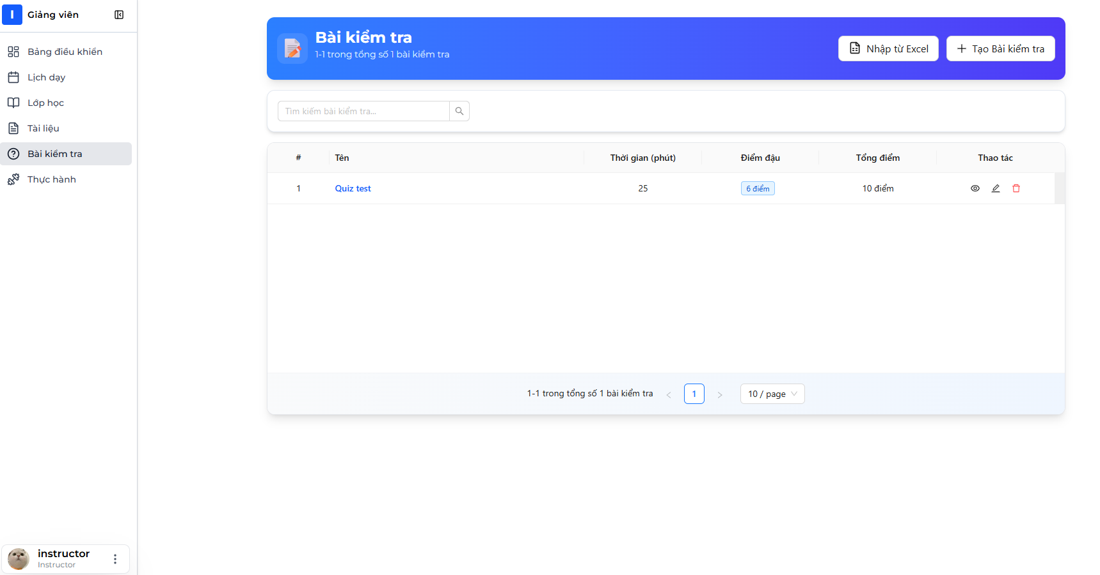

1. Quizzes list page displays showing your created quizzes



1. Click "Create New Quiz" button

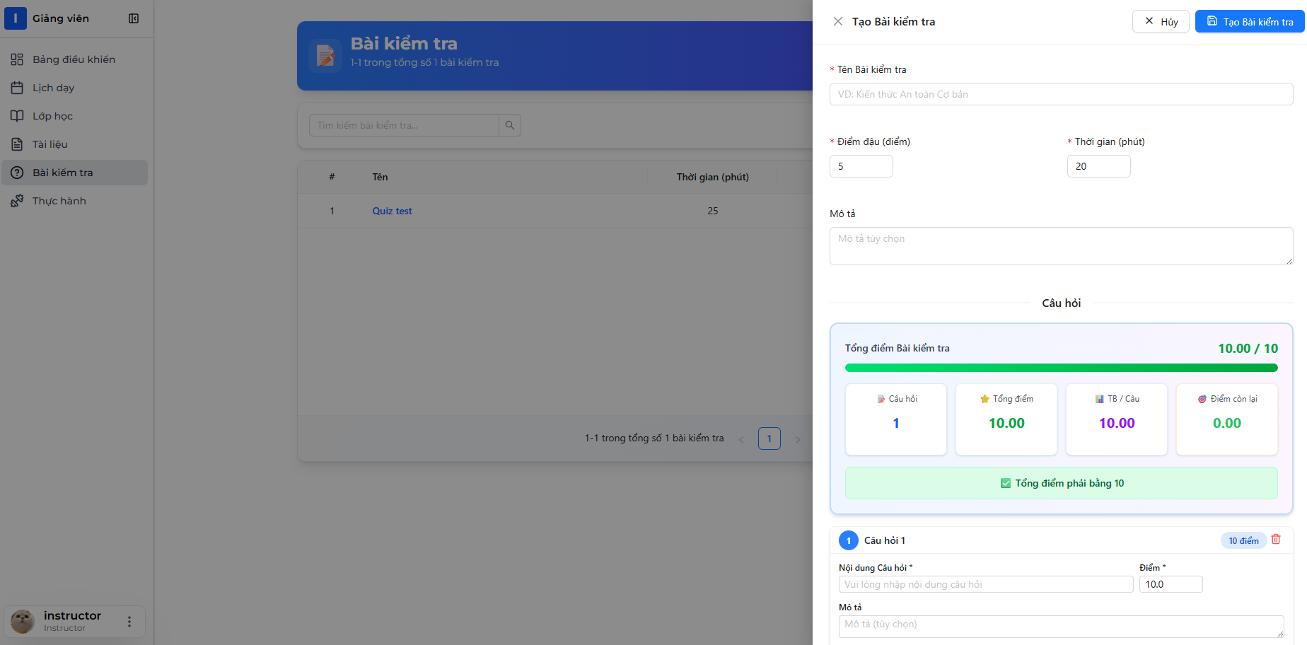

1. Quiz creation form opens (may be multi-step)

Step 1: Quiz Basic Information

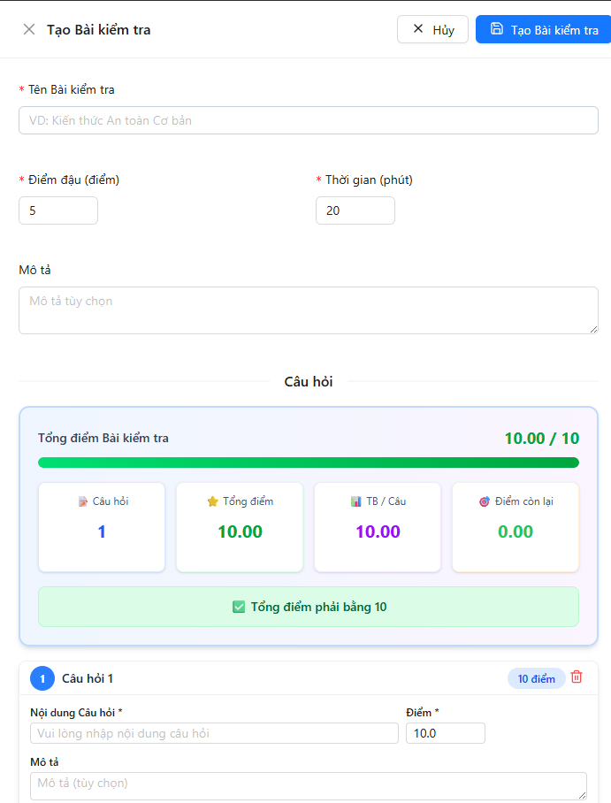

1. Fill in quiz information:
   * Quiz Name: "Mobile Crane Safety Assessment"
   * Description: "Test your knowledge of crane safety procedures"
   * Duration: 30 minutes
   * Passing Score: 7
2. Click "Next"

Step 2: Add Questions

📷 INSERT SCREENSHOT HERE: Add Questions Section

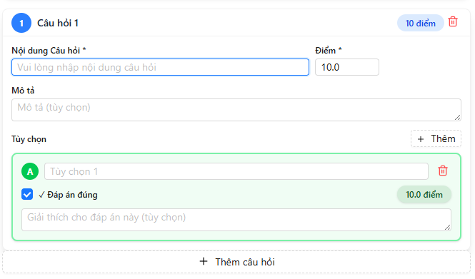

1. Click "Add Question" button
2. Question form appears



1. Fill in question details:
   * Question Text: "What is the safe minimum distance from a power line for crane operations?"
   * Score Points:10
   * Explanation: "Regulations often require at least 10 meters depending on voltage."
2. Add Options:
   * Click "Add Option" button for each option

📷 INSERT SCREENSHOT HERE: Add Option Interface

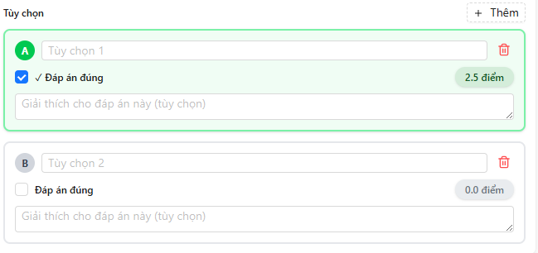

1. Enter options:
   * Option 1: "1 meter" (not correct)
   * Option 2: "3 meters" (not correct)
   * Option 3: "10 meters" (check "Is Correct")
   * Option 4: "50 meters" (not correct)

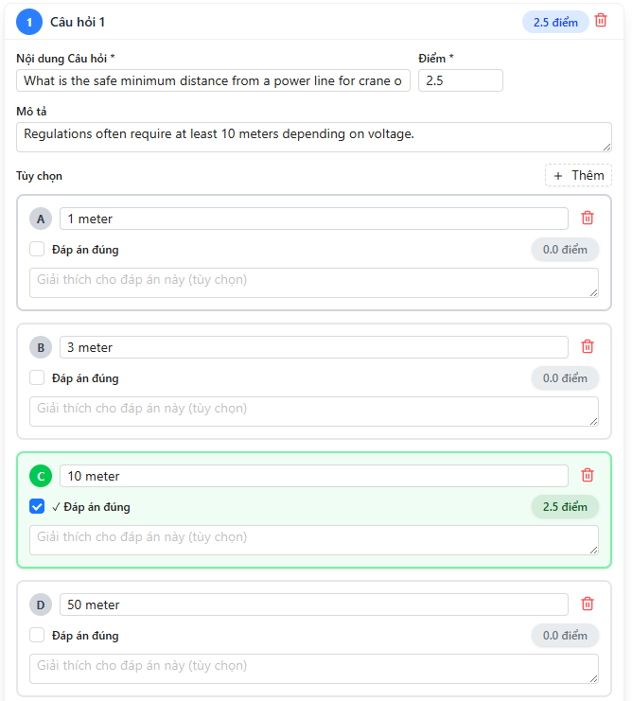

1. Click "Save Question"
2. Question is added to quiz questions list

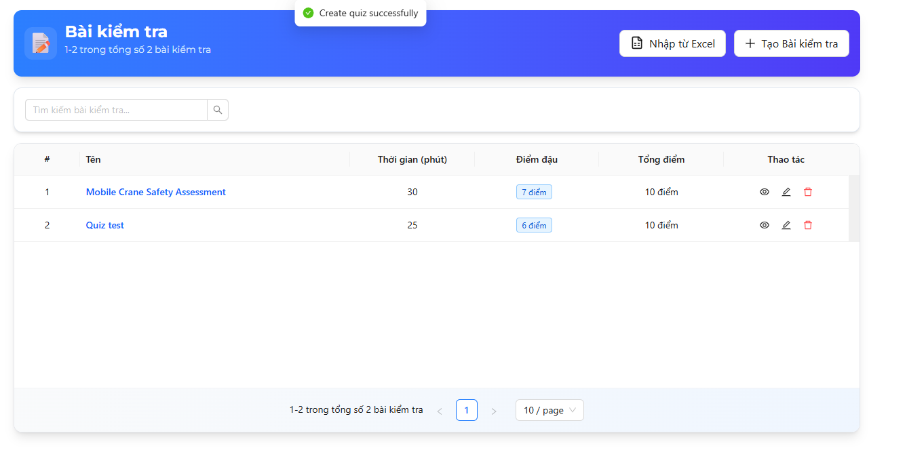

1. Repeat steps 9-15 to add more questions
   * Add at least 2-10 questions per quiz



1. Review Quiz:
   * Check all questions are added
   * Verify total points
   * Ensure at least one correct option per question
2. Click "Save Quiz" button
3. Success message: "Quiz created successfully"



API Endpoint Used:

POST /api/Quizzes/with-questions

Request Body:

{

"name": "Mobile Crane Safety Assessment",

"description": "Test your knowledge.. .",

"durationMinutes": 30,

"passingScore": 70,

"isRandomizeQuestions": true,

"isRandomizeOptions": true,

"showCorrectAnswers": true,

"isActive": true,

"questions": [

{

"questionText": "What is the safe minimum distance.. .",

"score": 2.5,

"isMultiple": false,

"explanation": "Regulations often require.. .",

"options": [

{ "optionText": "1 meter", "isCorrect": false },

{ "optionText": "3 meters", "isCorrect": false },

{ "optionText": "10 meters", "isCorrect": true },

{ "optionText": "50 meters", "isCorrect": false }

]

},

{ ... more questions... }

]

}

Response (200 OK):

{

"status": 200,

"message": "Create quiz successfully",

"data": { "quizId": 45 }

}

###### 4.2 Import Quiz from Excel

Step-by-Step Instructions:

1. Download Excel template first:
   * Navigate to Quizzes page
   * Click "Import Quiz" dropdown
   * Select "Download Template"

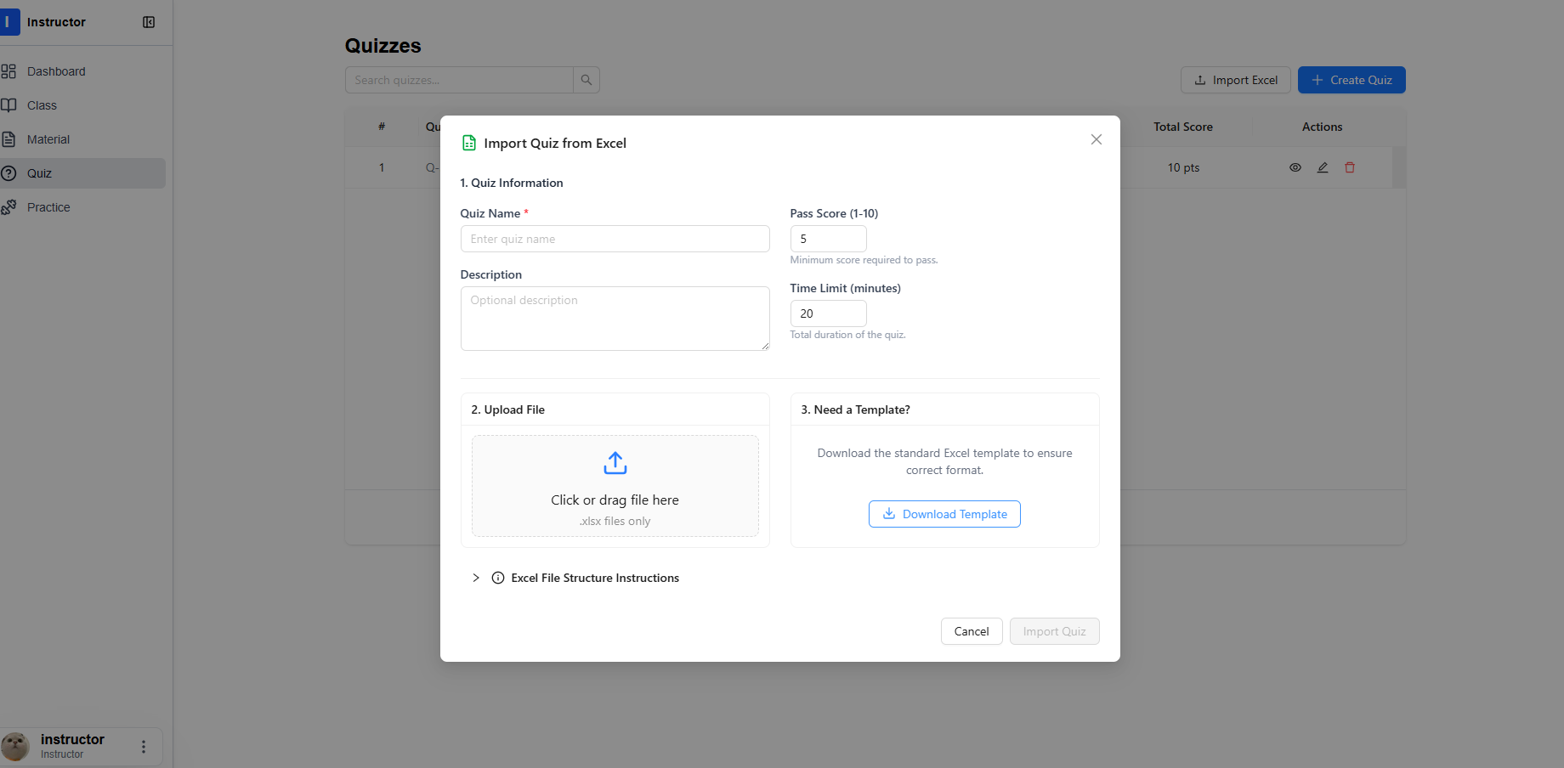

1. Template Excel file downloads

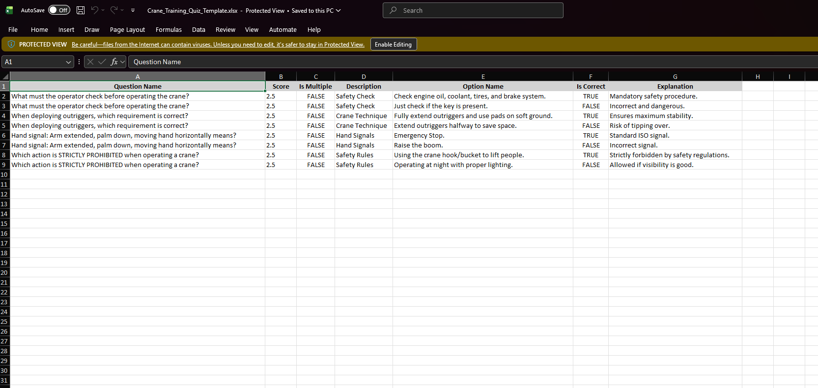

1. Fill in template:
   * Each question can have multiple rows (one per option)
   * Question Name must be same for all options of same question
   * Is Multiple: true/false
   * Is Correct: true/false (only ONE true for single choice)



1. Save Excel file as .xlsx format
2. Return to Quizzes page
3. Click "Import Quiz" → "Import from Excel"

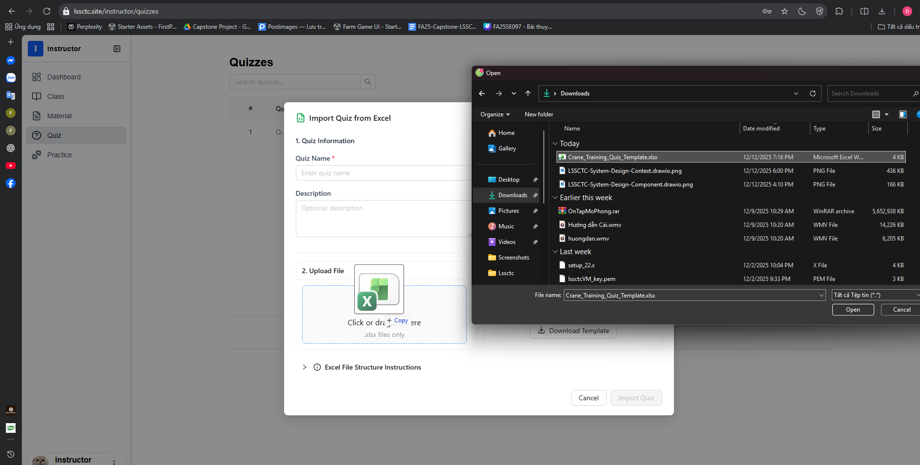

1. Drag file into drop zone or click "Browse Files"
2. Select your filled Excel file
3. File name appears in dialog

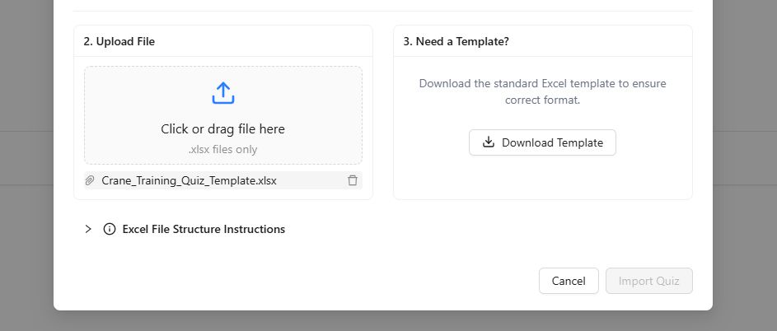

##### **f. Feature 5: Trainee - Practice Attempt 1. Download file exe**

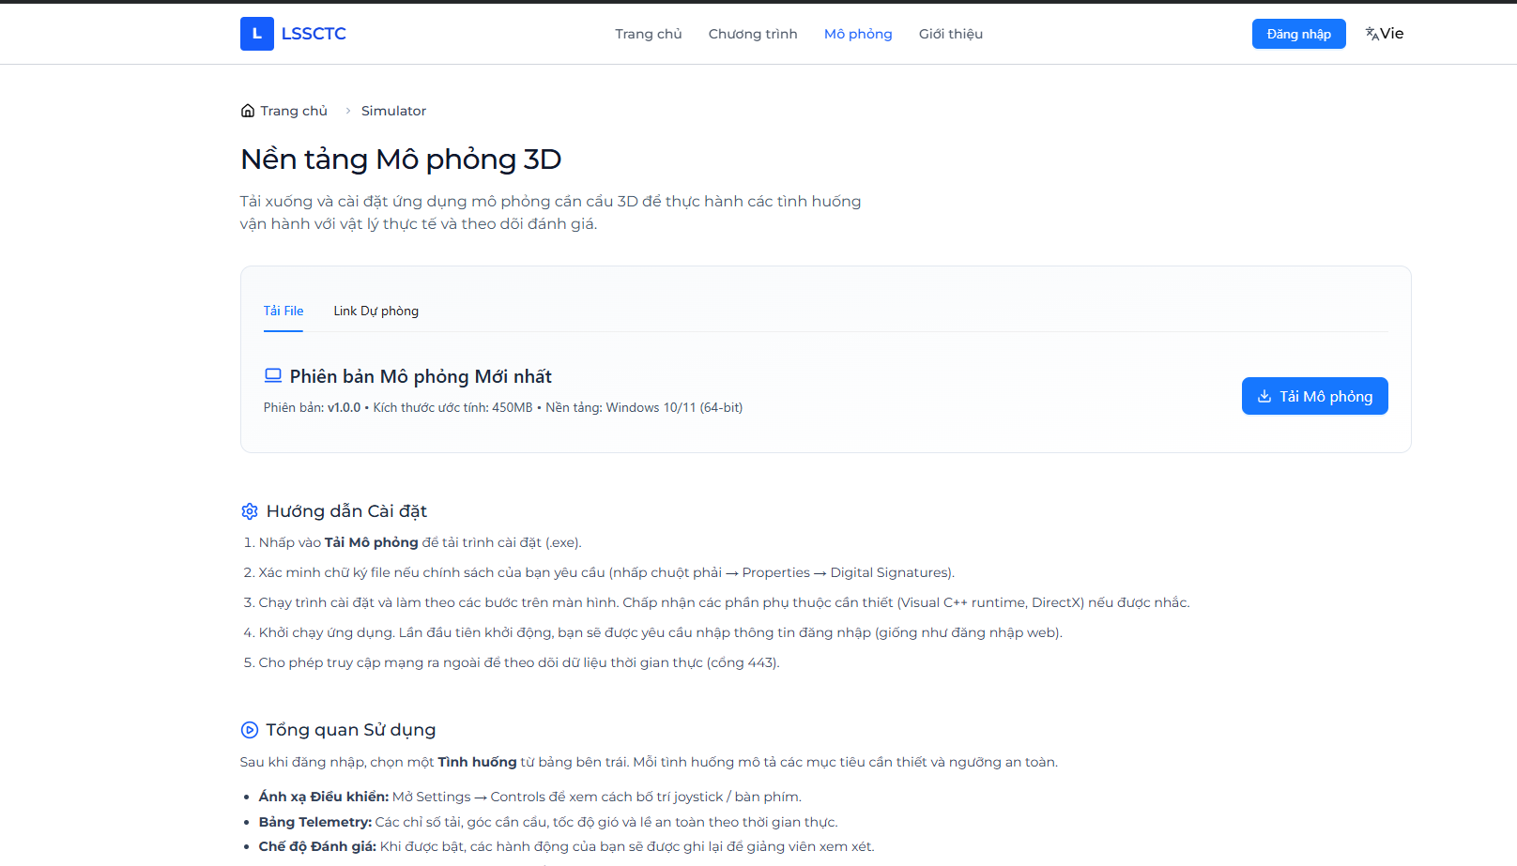

2. Open CraneSimulator.exe file

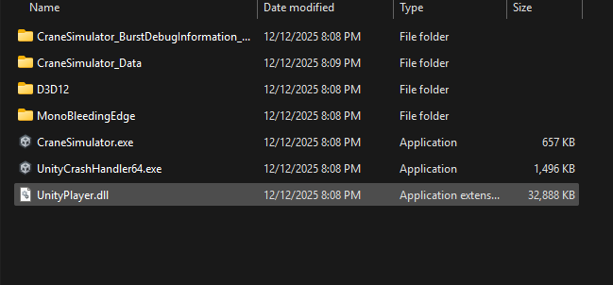

3. Login with username, password

  
 4. Select practice mode



5. Select Class

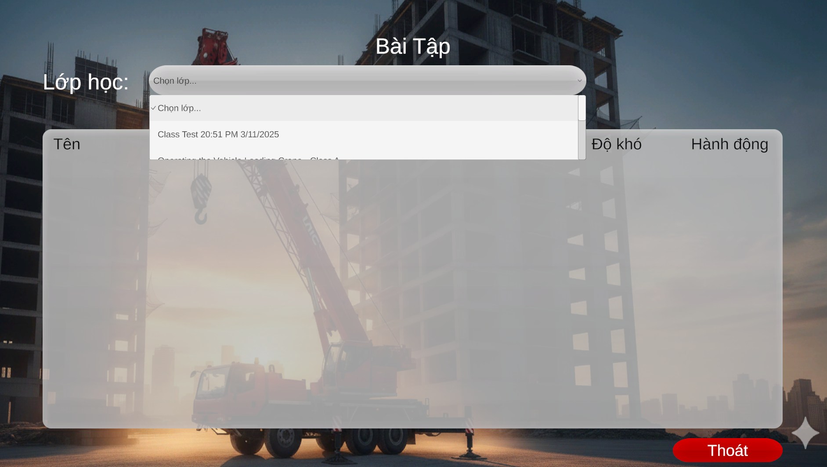

6. Select practice to start

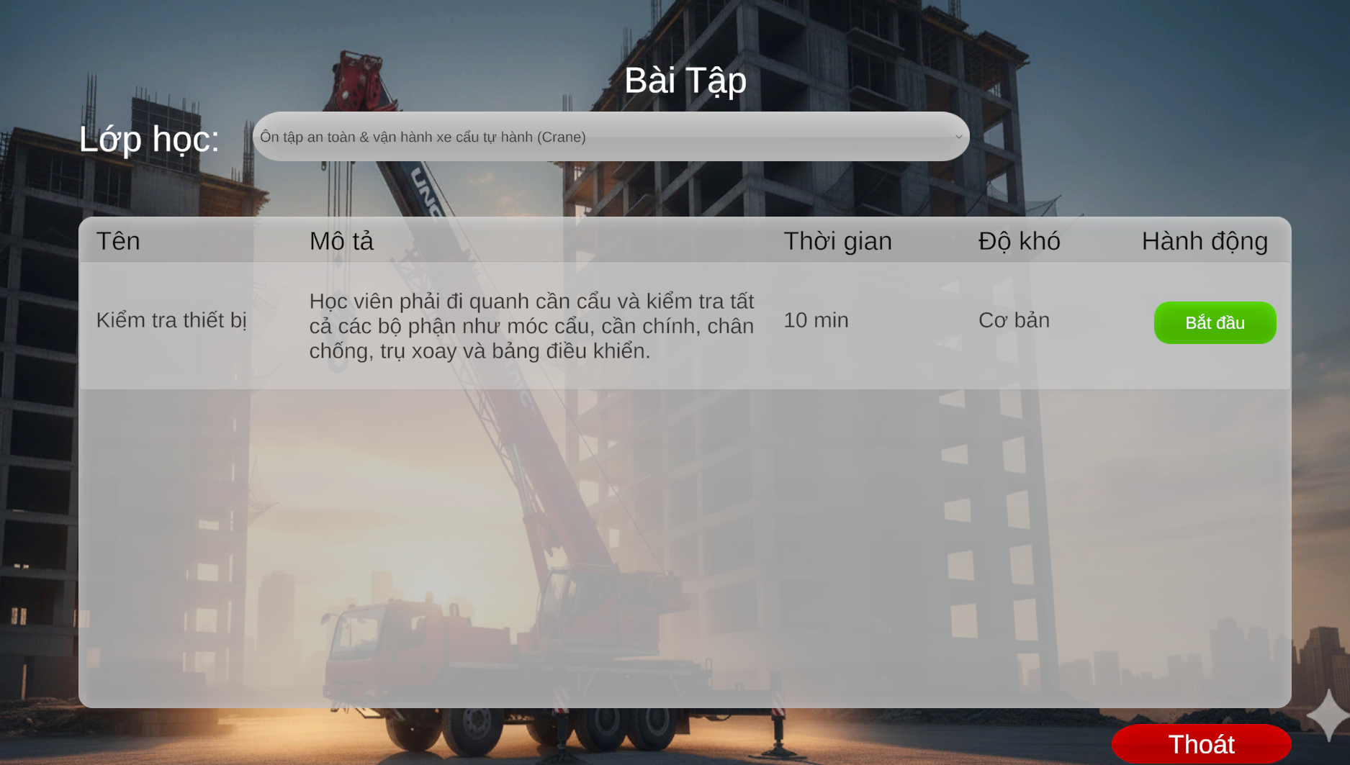

7. Finish practice